Ryan Blatti

ME 646

Lab 4 Pressure Tap

The two constants that were extracted from the data were the natural frequency and the damping ratio. First the damping ratio was extracted by locating all of the major peaks in the data that was collected. Once the peaks were located, they were put in to the damping ratio equation below.

$ζ= \frac{\frac{1}{n-1}ln⁡(\frac{y_{1}}{y_{n}})}{\sqrt{4π^{2}+{\left[\frac{1}{n-1}\ln\left(\frac{y_{1}}{y_{n}}\right)\right]}^{2}}}$ (1)

Once all of the peaks were entered into this equation there was an array of damping ratios. By taking the mean of all of these values we end up with one value for the damping ratio for every set of data.

The other constant that was extracted from the data was the natural frequency. The first step in finding the natural frequency is to find the period of the peaks in the data. once the period is found, it then can be plugged into the damped natural frequency equation below.

$ω_{d}= \frac{2π}{period }$ (2)

Once the damped natural frequencies are calculated, those values are then plugged into the natural frequency equation listed below.

$ω_{n}= \frac{ω_{d}}{\sqrt{1-ζ^{2}}}$ (3)

After the natural frequency is calculated the two constants have now been extracted from the data and are ready to use to plot the predicted data and the actual data.

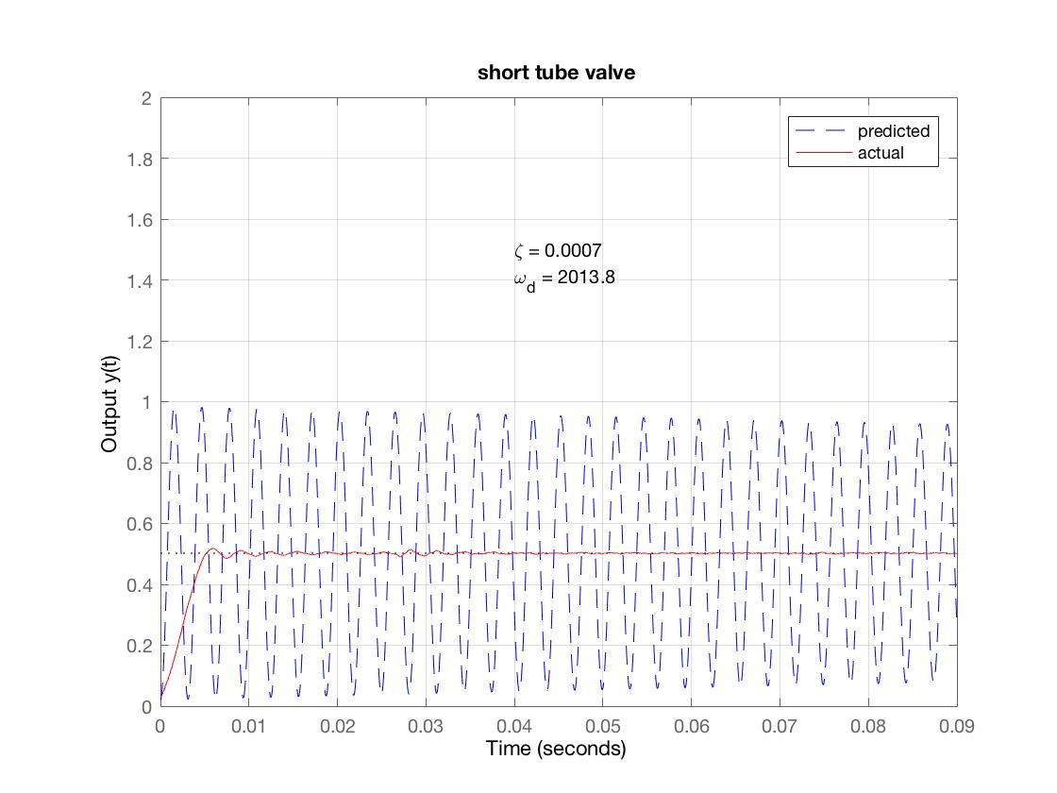

Figure 1: Short tube valve data

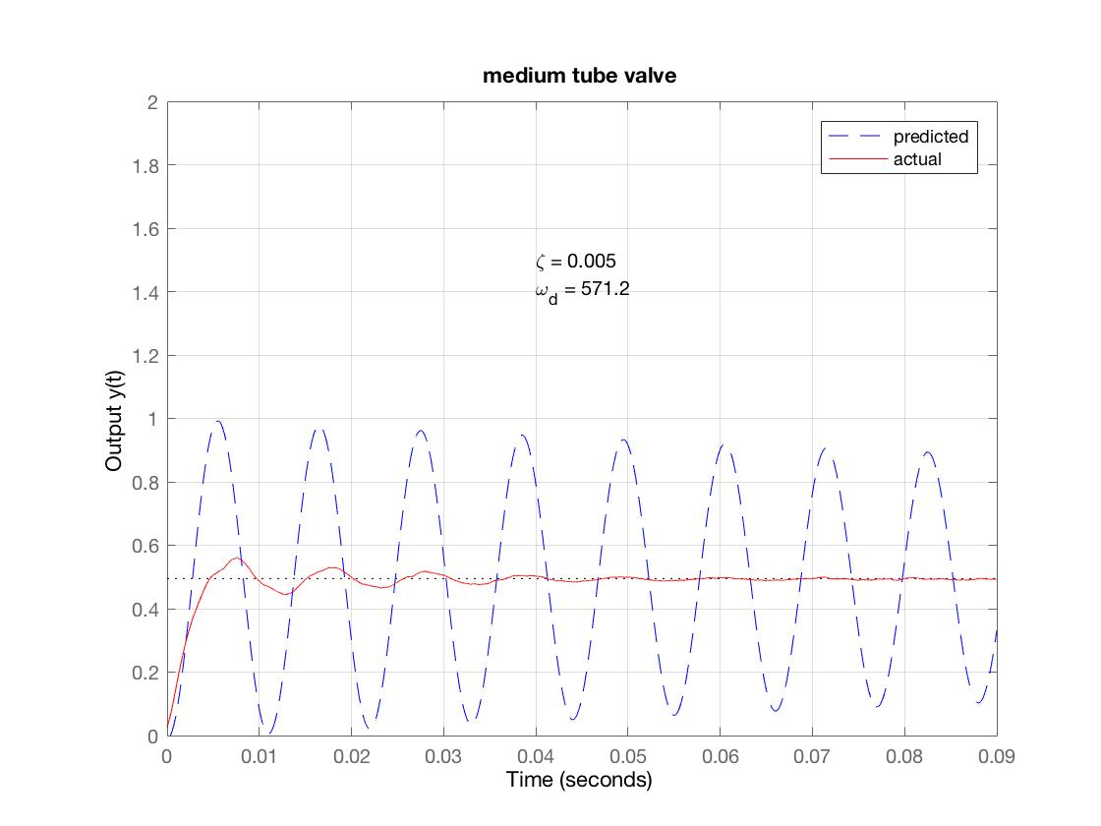

Figure 2: Medium tube valve data

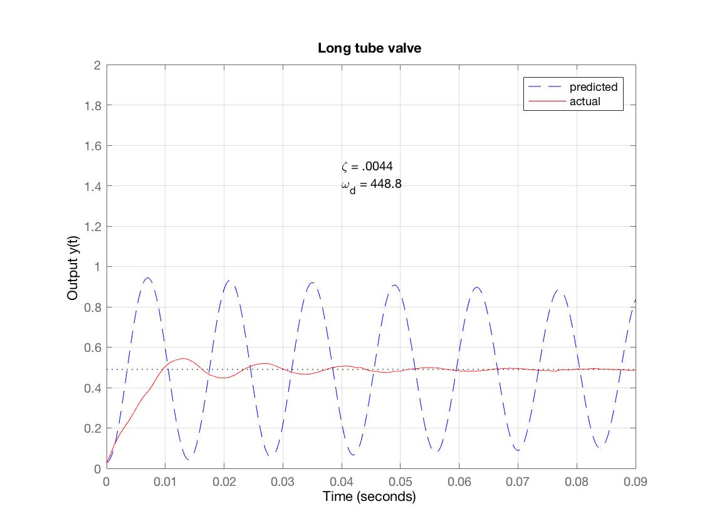

Figure 3: Long tube valve data

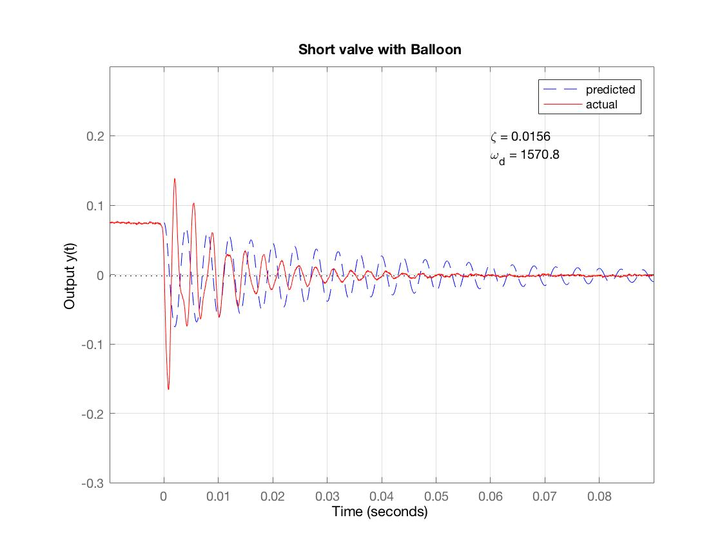

Figure 4: Short tube, balloon popping data

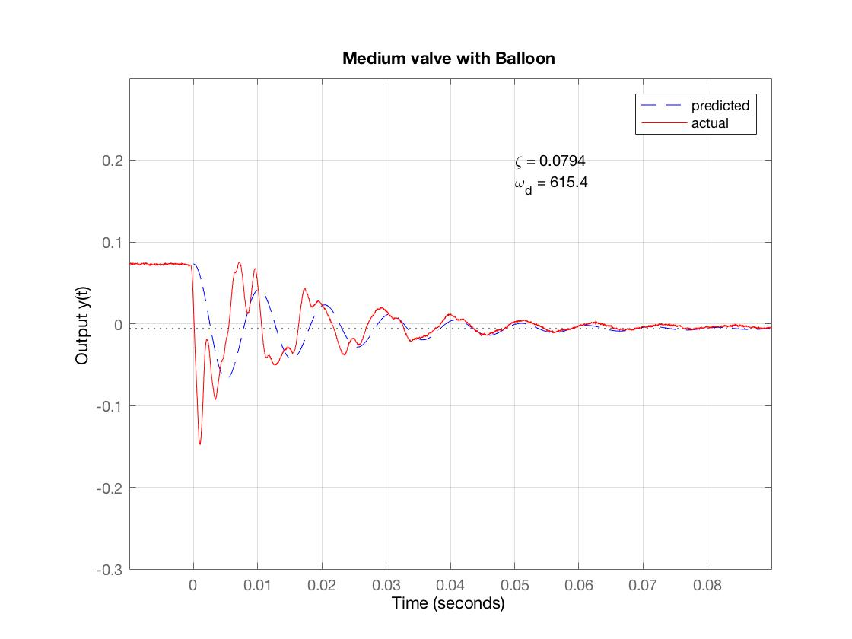

Figure 5: Medium tube, balloon popping data

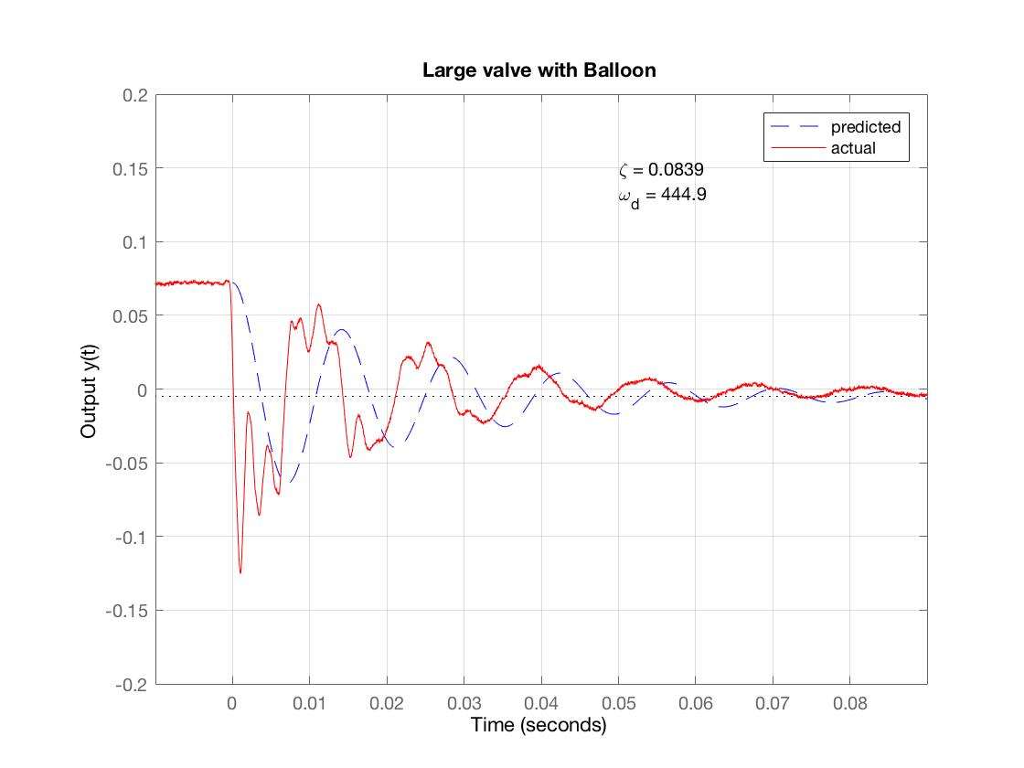

Figure 6: Long tube, balloon popping data

The equation that is used to get the predictions of the natural frequency is listed down below.

$ω_{n}= \frac{a}{l\sqrt{0.5+\frac{V}{V_{t}}}}$ (4)

In this equation, a is the speed of sound, which is 343 m/s. The L represents the length of the tube (m). V in this equation represents the volume (m^3)of the tube that is used, and Vt (m^3) is the volume of the pressure tap. With this equation we are able to plot the predicted natural frequency values and compare them to the natural frequencies that were extracted previously.



Figure 7: predicted natural frequencies

As you can see in figure 7 above, the graph displays a dependence to the inverse of tube length. The predicted slope is approximately equal to the natural frequencies that were previously found.

To get the prediction line for the damping ratios, the equation below is used.

$ζ= \frac{16μl}{aρd^{2}}\sqrt{0.5+\frac{V}{V_{t}}}$ (5)

$μ$ in this equation represents the viscosity of air, which is 1.81(10^-5) (kg/ms). $ρ$ in this equation represents the density of the air at room temperature, which is 1.225 (kg/m^3). The d in this equation stands for the diameter of the tube (m). The remaining variables are the same as the variables used in the equation to find the predicted natural frequency.



Figure 8: predicted damping ratios

As seen in figure 8 above, the graph exhibits a dependence to the length of the tube. The predicted slope is approximately equal to the damping ratios that were previously calculated.